LOMBA KOMPETENSI SISWA

SEKOLAH MENENGAH KEJURUAN

TINGKAT KABUPATEN LAMPUNG TENGAH XXVII – 2019

KISI-KISI

BIDANG LOMBA


WEB DESIGN AND DEVELOPMENT

KEMENTRIAN PENDIDIKAN DAN KEBUDAYAAN

DIREKTORAT JENDERAL PENDIDIKAN MENENGAH

DIREKTORAT PEMBINAAN SEKOLAH MENENGAH KEJURUAN

LKS SMK 2019 Bidang Lomba Web Design
- PENDAHULUAN

Kecepatan globalisasi yang pesat dalam dekade terakhir sebagian besar didorong oleh perkembangan Teknologi Informasi dan Komunikasi (TIK). Pakar IT semakin diminati di beberapa bidang, salah satunya adalah menyediakan solusi perangkat lunak untuk bisnis.

Pengembangan solusi perangkat lunak untuk meningkatkan produktivitas bisnis mencakup berbagai keterampilan dan disiplin ilmu. Kunci untuk ini adalah kesadaran akan sifat industri yang berubah dengan cepat dan kemampuan untuk mengikuti perubahan yang cepat.

Solusi profesional perangkat lunak TI selalu bekerja sama dengan klien untuk memodifikasi sistem yang ada atau menciptakan sistem baru. Mungkin juga memodifikasi perangkat lunak "pasaran" dan mengintegrasikannya ke dalam sistem yang ada. Mereka seringnya bekerja sebagai bagian dari tim profesional perangkat lunak yang bertanggung jawab atas spesifikasi kebutuhan, analisis dan perancangan sistem, konstruksi, pengujian, pelatihan, dan implementasi, serta pemeliharaan sistem perangkat lunak bisnis.

Tugas yang dilakukan oleh profesional solusi perangkat lunak TI termasuk namun tidak terbatas pada hal berikut:

  - Meninjau kembali sistem saat ini dan memberikan saran untuk perbaikan, termasuk analisis biaya manfaat serta menganalisis dan menentukan kebutuhan pengguna

  - Menghasilkan spesifikasi terperinci untuk sistem baru atau untuk modifikasi sistem yang ada

  - Mengembangkan sistem perangkat lunak dan menguji solusi perangkat lunak secara menyeluruh.

  - Mempersiapkan materi pelatihan pengguna, melatih pengguna, dan menyajikan solusi perangkat lunak kepada pengguna

  - Menginstal, menerapkan, dan memelihara sistem perangkat lunak

Para ahli dibidang Perangkat lunak untuk solusi Bisnis ini dapat berkarir di perusahaan besar, menengah, dan kecil sebagai ahli perangkat lunak, atau di perusahaan konsultan sebagai konsultan, dan kontraktor.

Kisi-Kisi LKS SMK XXVI Tahun 2018 Hal 1 dari 10

- SPESIFIKASI KOMPETENSI

Kompetisi ini dirancang untuk menguji keahlian pengguna perangkat lunak aplikasi khusus keterampilan yang terkait:
o Menganalisa sistem menggunakan alat dan teknik modeling database

dengan menggunakan Entity Relationship Diagram (ERD)

o Menggunakan kemampuan investigasi untuk mendapatkan kebutuhan pengguna ( pencarian dan analisa dokumen – dokumen))

o Menuliaskan fungsi bedasarkan sifat - sifatnya (inputs, outputs, pre-conditions and post-conditions).

o Menggunakan IDE terbaru dan mengidentifikasi kekuatan dan kelemahan dari setiap pengembangan aplikasi.

o Melakukan pencarian, evaluasi dan integrase libraries dan frameworks yang sesuai dan dibutuhkan oleh aplikasi yang dikembangkan.
o Mengembangkan struktur database dan kamus data.

o Menggunakan fungsionalitas .NET environment untuk mengembangkan

solusi aplikasi bedasarkan spesifikasi yang dibutuhkan.
o Menggunakan SQL Server untuk menyimpan dan mengatur data untuk

sistem yang dikembangkan.
o Mengembangkan aplikasi multi - tier

o Mengembangkan aplikasi mobile untuk client-server based system

o Melakukan demo aplikasi yang dikembangkan untuk menyelesaikan kasus

bisnis yang diberikan.

o Melakukan presentasi aplikasi di depan klien untuk memberikan rangkuman fungsional dari aplikasi yang dikembangkan.

Deskripsi Teknis Analisis

Dari list technical description di atas, dapat di rangkum menjadi :

  - Work Organization and Management

  - Communication and Interpersonal Skill

  - Problem Solving, innovation and Creativity

  - Analyze and Designing Software Solution

  - Developing Software Solution

  - Testing Software Solution

  - Documenting Software Solution

Kisi-Kisi LKS SMK XXVI Tahun 2018 Hal 2 dari 10
Secara umum akan terbagi dalam 5 modul utama

Module | Software
 | Microsoft Visual Studio Community
Database Creation and Main | Edition 2015, SQL Server Express
Form Development | Management Studio 2014, and SQL
 | server 2014 (Express Edition)
 | Microsoft Visual Studio Community
Master Form Development | Edition 2015, SQL Server Express
Master Form Development | Management Studio 2014, and SQL
 | server 2014 (Express Edition)
 | Microsoft Visual Studio Community
Transaction Form Development | Edition 2015, SQL Server Express
Transaction Form Development | Management Studio 2014, and SQL
 | server 2014 (Express Edition)
 | SQL Server Express Management Studio
Database Development | 2014, and SQL server 2014 (Express
 | Edition)
Mobile Application Development | Android Studio Versi 2.3.3.

- STRATEGI ASESMEN DAN SPESIFIKASI

  - Penilaian hasil lomba akan dilakukan per modul setelah setiap modul selesai.

  - Peserta lomba yang mampu menyelesaikan satu modul lomba sebelum waktu pengumpulan (selesai lebih cepat) diizinkan untuk mulai mengerjakan modul berikutnya.

  - Peserta tidak diperkenankan mengerjakan atau merevisi modul yang sudah lewat / sudah selesai dan yang sudah dikumpulkan.

  - Peserta lomba tidak diperbolehkan membawa materi elektronik dan cetak ke area kompetisi.

  - Juri akan memberi nilai berdasarkan daftar cek yang ada (marking form). Untuk setiap list yang ada mungkin berisi lebih dari satu komponen penilaian. Hasil yang salah atau tidak benar pada salah satu komponen tersebut akan dianggap sebagai jawaban yang salah.

- SKEMA PENILAIAN

Persentase penilaian:

- Database Creation and Main Form Development

o Master Form Development

o Transaction Form Development o ERD Design and Data Dictionary

- Mobile Application Development

- 17%

- 21%

- 32%

- 15%

- 15%

Kisi-Kisi LKS SMK XXVI Tahun 2018 Hal 3 dari 10

- PROYEK UJI LKS

Spesifikasi yang dibutuhkan dan aspek detail yang di uji sebagai berikut:

  - Database Creation and Main Form Development

    - Creating physical model of the database

o All entities are translated into database objects as instructed in the

test project
o Define the relationship between the entities

o All the constraint required are implemented to support the system

    - Creating Application Main Form

o Login Form work using existing user data and roles o Navigation Form to navigate between form

o Information Form can show instructed information

o Showing media on application such as picture / video files

  - Master Form Development

    - All master form developed can support the business process flow required in the test project

    - Database query and connection are working correctly

o creating connection between application and the database o query to display data

o query to insert data o query to update data o query to delete data o query to search data o query to sorting data

    - Uploading Files to the Application

    - Auto-searching on Data Tables from text boxes input

    - Date and Time Validation

  - Transaction Form Development

    - All transaction form developed can support the business process flow required in the test project

    - Database query and connection are working correctly

o creating connection between application and the database o query to display data, Join Table, Aggregate

o query to insert data o query to update data o query to delete data o query to search data

    - Programming logic to solve given requirements

    - Date and Time Validation

    - Date Format

    - Number and String Format

Kisi-Kisi LKS SMK XXVI Tahun 2018 Hal 4 dari 10

    - Chart Component in .net

    - Report in .net

  - Database Development

    - Solve the given case by designing Database in Sql Server

    - Relationship defining every two participating entities

    - Attributes defining the properties of entities

    - Cardinality defining number of instance of an entity from a relation that can be associated with the relation

    - Providing the Data each table.

  - Mobile Application Development

    - All mobile application form developed can support the business process flow in the test project.

    - Programming logic to solve given requirements

    - Number and String Format

    - Database Query / File Read to display data in mobile application

LKS SMK

Tingkat Kabupaten
Lampung Tengah Ke-XXVII

Tahun 2019

 | TINGKAT KABUPATEN LAMPUNG TENGAH
Soal | Tingkat asional XXVII
Soal | 2019
BIDANG LOMBA

IT-Software Solution for Business

KEMENTERIAN PENDIDIKAN DAN KEBUDAYAAN

DIREKTORAT JENDERAL PENDIDIKAN MENENGAH DIREKTORAT PEMBINAAN SEKOLAH MENENGAH
PROJECT OVERVIEW

In this Test Project, you are required to develop an information system following the requirement given on the Test Project. In general, there will be 4 project resources given to you, which is:

- ERD and Data Dictionary for Test Project

This will be used to guide you to create the database files. Ensure that all entities created on the database are related with the given ERD, following the relationship and also the criteria in Data Dictionary for each entity!

- Navigation Diagram for the Application

Use the Navigation Diagram to develop the form interaction inside the application. You are free to add new interaction between forms, without neglecting the defined interaction in this diagram.

- Example Design (Wireframe) of desired Information System

This file is used to give you design guidelines of all required forms. Please note that your form designs are not limited to these examples!

- Data files (if any)

The data files will be used to support you test and develop the information system on each module. Please use this data files in the development, you are allowed to use another resources outside the given data files only if instructed in the module.

Soal LKS SMK XXVI Tahun 2018 Hal 2 dari 18

SMK NUSANTARA INFORMATION SYSTEM

ENTITY RELATIONSHIP DIAGRAM
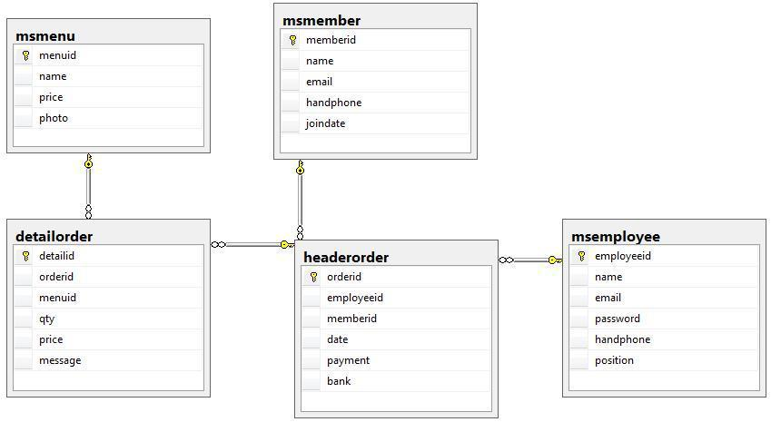

Soal LKS SMK XXVI Tahun 2018 Hal 3 dari 18

SMK NUSANTARA INFORMATION SYSTEM

DATA DICTIONARY

 |  | Tabel |  |  | KEY |  |  | Kolom |  |  | Tipe Data |  |  | Required? |  |  | Notes
 |  |  |  |  |  |  |  |  |  |  |  |  |  |  |  |  | Auto
 |  |  |  |  | PK |  |  | MenuID |  |  | INTEGER |  |  | Y |  |  | Increment
 |  | Msmenu |  |  |  |  |  | Name |  |  | nVARCHAR(50) |  |  | Y
 |  |  |  |  |  |  |  | Price |  |  | INTEGER |  |  | Y
 |  |  |  |  |  |  |  | Photo |  |  | nVARCHAR(100) |  |  | Y
 |  |  |  |  |  |  |  |  |  |  |  |  |  |  |  |  | Auto
 |  |  |  |  | PK |  |  | MemberID |  |  | nchar(8) |  |  | Y |  |  | Increment
 |  | Msmember |  |  |  |  |  | Name |  |  | nVARCHAR(50) |  |  | Y
 |  | Msmember |  |  |  |  |  | Email |  |  | nVARCHAR(50) |  |  | Y
 |  |  |  |  |  |  |  | Handphone |  |  | nVARCHAR(13) |  |  | Y
 |  |  |  |  |  |  |  | JoinDate |  |  | Date |  |  | Y
 |  |  |  |  |  |  |  |  |  |  |  |  |  |  |  |  | Auto
 |  |  |  |  | PK |  |  | EmployeeID |  |  | nchar(6) |  |  | Y |  |  | Increment
 |  |  |  |  |  |  |  | Name |  |  | nvarchar(100) |  |  | Y
 |  | Msemployee |  |  |  |  |  | Email |  |  | nvarchar(50) |  |  | Y
 |  |  |  |  |  |  |  | password |  |  | nvarchar(50) |  |  | Y
 |  |  |  |  |  |  |  | Handphone |  |  | nvarchar(13) |  |  | Y
 |  |  |  |  |  |  |  | Position |  |  | nvarchar(50) |  |  | Y
 |  |  |  |  |  |  |  |  |  |  |  |  |  |  |  |  | Auto
 |  |  |  |  | PK |  |  | OrderID |  |  | nchar(10) |  |  | Y |  |  | Increment
 |  |  |  |  | FK |  |  | Employeeid |  |  | nchar(6) |  |  | Y
 |  | Headerorder |  |  | FK |  |  | Memberid |  |  | nchar(8) |  |  | Y
 |  |  |  |  |  |  |  | Date |  |  | Date |  |  | Y
 |  |  |  |  |  |  |  | Payment |  |  | nvarchar(50) |  |  | Y
 |  |  |  |  |  |  |  | bank |  |  | nvarchar(50) |  |  | Y
 |  |  |  |  |  |  |  |  |  |  |  |  |  |  |  |  | Auto
 |  |  |  |  | PK |  |  | Detailid |  |  | INTEGER |  |  | Y |  |  | Increment
 |  |  |  |  | FK |  |  | Orderid |  |  | nchar(10) |  |  | Y
 |  | Detailorder |  |  | FK |  |  | Menuid |  |  | INTEGER |  |  | Y
 |  |  |  |  |  |  |  | Qty |  |  | INTEGER |  |  | Y
 |  |  |  |  |  |  |  | Price |  |  | INTEGER |  |  | Y
 |  |  |  |  |  |  |  | status |  |  | VARCHAR(10) |  |  | Y

Soal LKS SMK XXVI Tahun 2018 Hal 4 dari 18

SMK NUSANTARA INFORMATION SYSTEM

WIREFRAME

01 Login Form
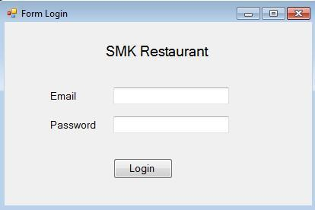

02 Admin Navigation Form
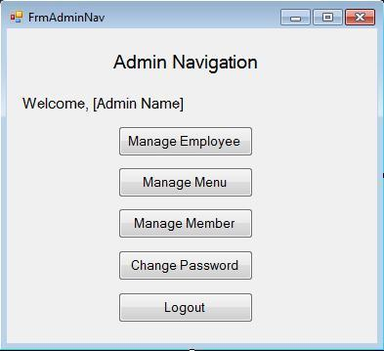

Soal LKS SMK XXVI Tahun 2018 Hal 5 dari 18

03 Chef Navigation Form
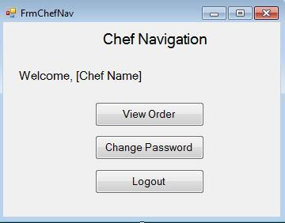

04 Cashier Navigation Form
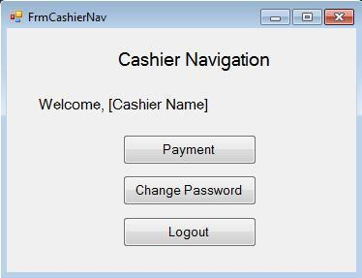

05 Manage Employee Form

Soal LKS SMK XXVI Tahun 2018 Hal 6 dari 18

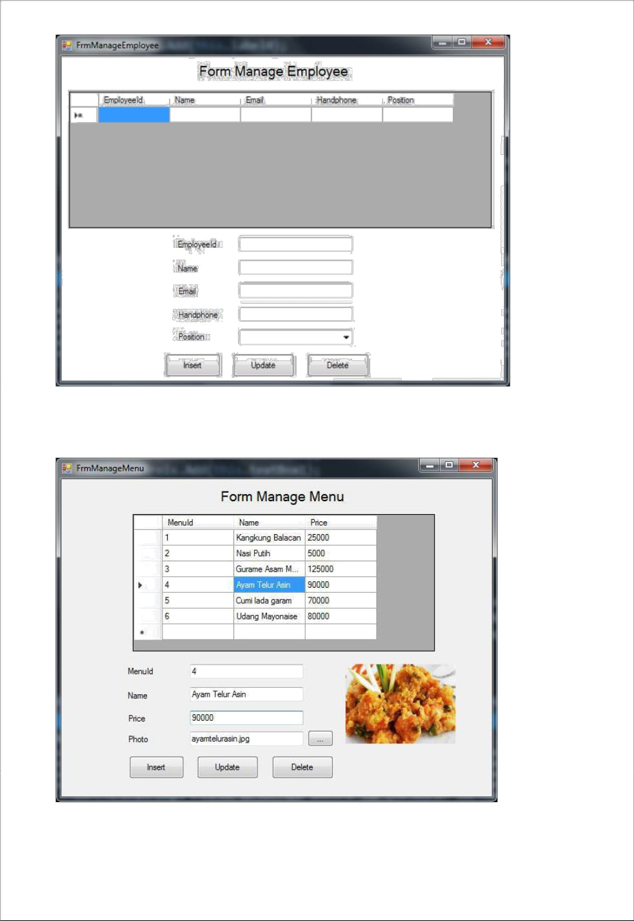

06 Manage Menu Form

Soal LKS SMK XXVI Tahun 2018 Hal 7 dari 18

07 Manage Member Form
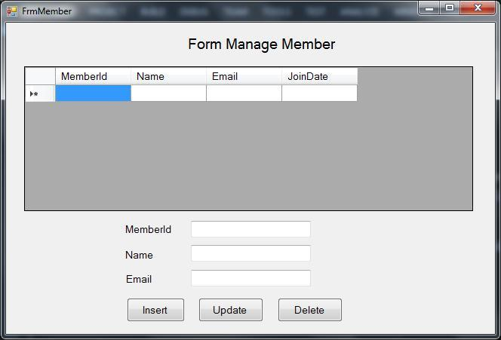

08 Change Password Form
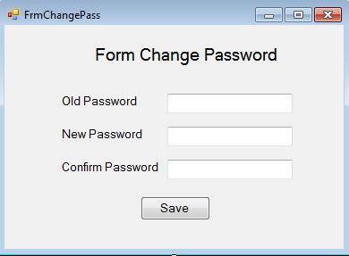

Soal LKS SMK XXVI Tahun 2018 Hal 8 dari 18

09 Order Form
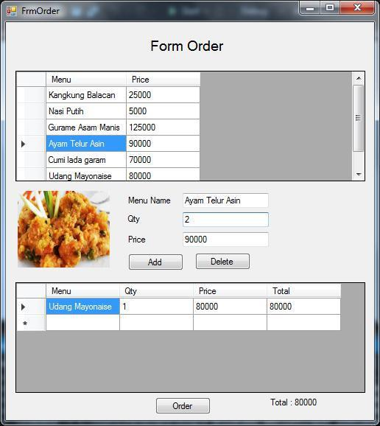

10 View Order Form
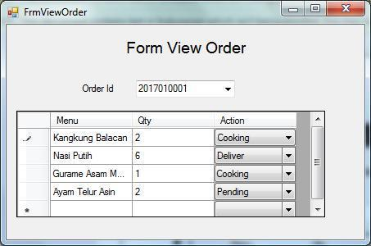

Soal LKS SMK XXVI Tahun 2018 Hal 9 dari 18

11 Payment Form
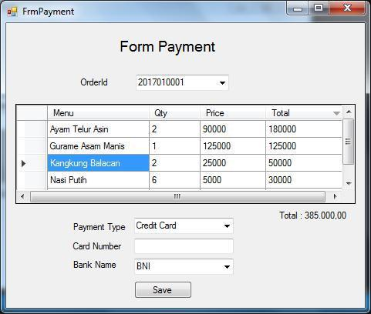

12 Report Form
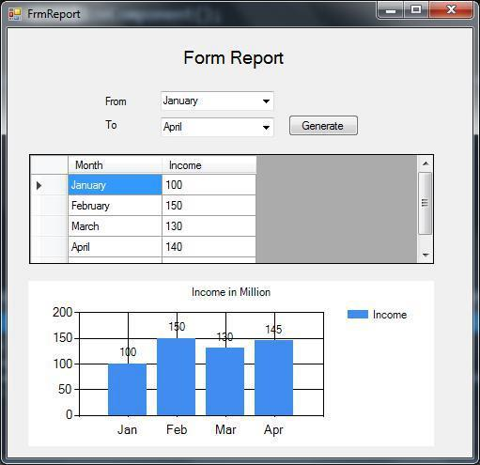

Soal LKS SMK XXVI Tahun 2018 Hal 10 dari 18

THE DEVELOPMENT OF

SMK Restaurant INFORMATION SYSTEM

SMK Restaurant is one of Indonesia famous vocational restaurant located in Malang, East Java. As the school growth, the Headmaster thinks it is the time to use Information System to support their business process for transaction process. After hiring famous consultant to analyze and design the system, it is the time to develop the system.

Based on the system design given to you, you’re required to develop Information system to support the business process of transaction for SMK Restaurant. Ensure your developed solutions can accommodate SMK Restaurant business process properly, following the instruction on the project!

Soal LKS SMK XXVI Tahun 2018 Hal 11 dari 18

Module 1: Database Creation and Main Form Development

3. Create the Database

Create a database using your MS SQL Server on the local database server following the ERD and Data Dictionary given to you.

4. Insert the Data

Insert the master data given to you on file “master-data.xlsx” to the related table on your newly created database.

5. Create Application

Create an application using your preferred platform (C# or Visual Basic.NET).

6. Create “01 Login Form”

Create the main menu of the application as outlined in “01 Login Form” in the wireframe.

Ensure all field must be filled.

Ensure Email and password must be existed in database

- Create “02 Admin Navigation Form”

Create the main menu of the application as outlined in “02 Admin Navigation Form” in the wireframe.

Ensure this form just can be accessed by Admin

Soal LKS SMK XXVI Tahun 2018 Hal 12 dari 18

5. Create “03 Chef Navigation Form”

Create the main menu of the application as outlined in “03 Chef Navigation Form” in the wireframe.

Ensure this form just can be accessed by Chef

6. Create “04 Cashier Navigation Form”

Create the main menu of the application as outlined in “04 Cashier Navigation Form” in the wireframe.

Ensure this form just can be accessed by Cashier

7. Create “08 Change Password Form”

Create the main menu of the application as outlined in “08 Change Password Form” in the wireframe.

Ensure old password input correctly

Ensure confirm password must be same with new password

Ensure new password must be containts uppercase, lowercase and number.

Soal LKS SMK XXVI Tahun 2018 Hal 13 dari 18

Module 2: Master Form Development

6. Create “05 Manage Employee Form”

Create the main menu of the application as outlined in “05 Manage Employee Form” in the wireframe.

Ensure display all Employee data stored inside the database

Ensure all data are filled before adding or updating the data.

Ensure EmployeeID auto generated correctly.

The Add New, Edit Data, and Delete Data button are functioned correctly.

As for Save and Cancel button, it only enabled when the user choose to Edit the Data, and should be on the proper state, if the user are editing the data cancel button should cancel the edited data.

7. Create “06 Manage Menu Form”

Create the main menu of the application as outlined in “06 Manage Menu Form” in the wireframe.

Ensure the form can display all Menu data stored inside the database

Ensure all data are filled before adding or updating the data.

The Add Data, Edit Data, and Delete Data button are functioned correctly.

As for Save and Cancel button, it only enabled when the user choose to Edit the Data, and should be on the proper state, if the user are editing the data cancel button should cancel the edited data.

Soal LKS SMK XXVI Tahun 2018 Hal 14 dari 18

2 Create “07 Manage Member Form”

Create the main menu of the application as outlined in “07 Manage Member Form” in the wireframe.

Ensure the form can list all Member data stored inside the database

Ensure all data are filled before adding or updating the data.

The Add Data, Edit Data, and Delete Data button are functioned correctly.

As for Save and Cancel button, it only enabled when the user choose to Edit the Data, and should be on the proper state, if the user are editing the data cancel button should cancel the edited data.

Soal LKS SMK XXVI Tahun 2018 Hal 15 dari 18

Module 3: Transaction Form Development

7. Create “09 Order Form”

Create the main menu of the application as outlined in “09 Order Form” in the wireframe.

Ensure all menu display in this form.

Ensure user can add and remove selected menu.

8. Create “10 View Order Form”

Create the main menu of the application as outlined in “10 View Order Form” in the wireframe.

Ensure the form can list all order that not finish yet

Ensure chef can change status every menu

9. Create “11 Payment Form”

Create the main menu of the application as outlined in “11 Payment Form” in the wireframe.

Ensure the form can list all order that not finish yet

Ensure all data inputted correctly before saving the data.

- Create “12 Report Form”

Create the main menu of the application as outlined in “12 Report Form” in the wireframe.

Soal LKS SMK XXVI Tahun 2018 Hal 16 dari 18

Module 4: Database Development

SMK Restaurant is going to continue the development of their Information System to support another business process of the Restaurant.

This new feature is used to give more information to people about food in this restaurant. Every guest can give their review and rating about food that they ordered. In this feature, people also can upload their picture about their ordered food. Every user can see menu picture, rating and review that made by user before.

Another thing to analyze, SMK Restaurant want to make party package that consist of some menu that already existed. For example, silver package consist of 2 meat menu and 2 vegetables menu. gold package is consist of 2 meat menu and 3 vegetables. Diamond package is consist of 3 meat menu and 3 vegetables. Every package have different price and have minimum order of 100 portions.

As an analyst, you are asked for create table and give example data minimum 5 data per table in SQL Server 2014 to support all system that needed in SMK Restaurant Review.

Soal LKS SMK XXVI Tahun 2018 Hal 17 dari 18

Module 5: Mobile Application Development

- Create “Mobile Application”

Create Application based on your Database.

Ensure your application can handle all business process in SMK Restaurant Review

The application must connect with your database that you have made in

module 4.

Make Form Validation that needed in your application, for an example “all data must be filled”

Soal LKS SMK XXVI Tahun 2018 Hal 18

dari 18

